To: Ministry and Committee Chairs

From: Shirley Geisler

Date: Wednesday, February 19, 2014

Dear Friends,

I am excited to begin in the new position as Director of Communication. As I suspect most of us on the Council may feel, I’m not exactly sure how all of this is going to look for me in this role, but as I’m learning in our “Journey”, I just need to take the steps with God, and He will direct my path.

I will be representing those ministries under “Communication” on the Ministry Council, and I will keep a focus on how we communicate as a church. Communicating with words is critical, but there are many ways we communicate non-verbally. When people come through the door, what impressions are they likely to make by what they see and hear? I will be working with many in the church on all aspects of communication.

Another part of my responsibility as outlined in my position description is to work with all ministries and committees in areas that involve communication. Not only am I fairly competent in creating brochures, PowerPoints, spreadsheets, promotional flyers and posters, there are other individuals in the church gifted in computer and graphic design as well. We offer our skills to you and your team.

If you need something developed for communication purposes, whether it is a PowerPoint presentation for a business meeting or other event, slides with music for one of your ministry gatherings or a church service, or a spreadsheet of numbers and information, we can do that for you. If you need assistance communicating anything to another group, I can assist you or direct you to where you can get that assistance.

Also anything you wish to communicate onto the Web or Facebook, if it meets the policy guidelines outlined for those areas, simply send it to me and we’ll work together in creating the message you wish to convey.

I’m excited to get busy in the area of communication and take our church and her ministries and committees to the next level of service to our church membership and the community.

God bless you all in your very important work and most especially your walk with God, and …

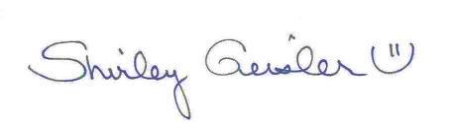Keep looking Up!

Shirley Geisler

Director of Communication

First Baptist Church of Gresham